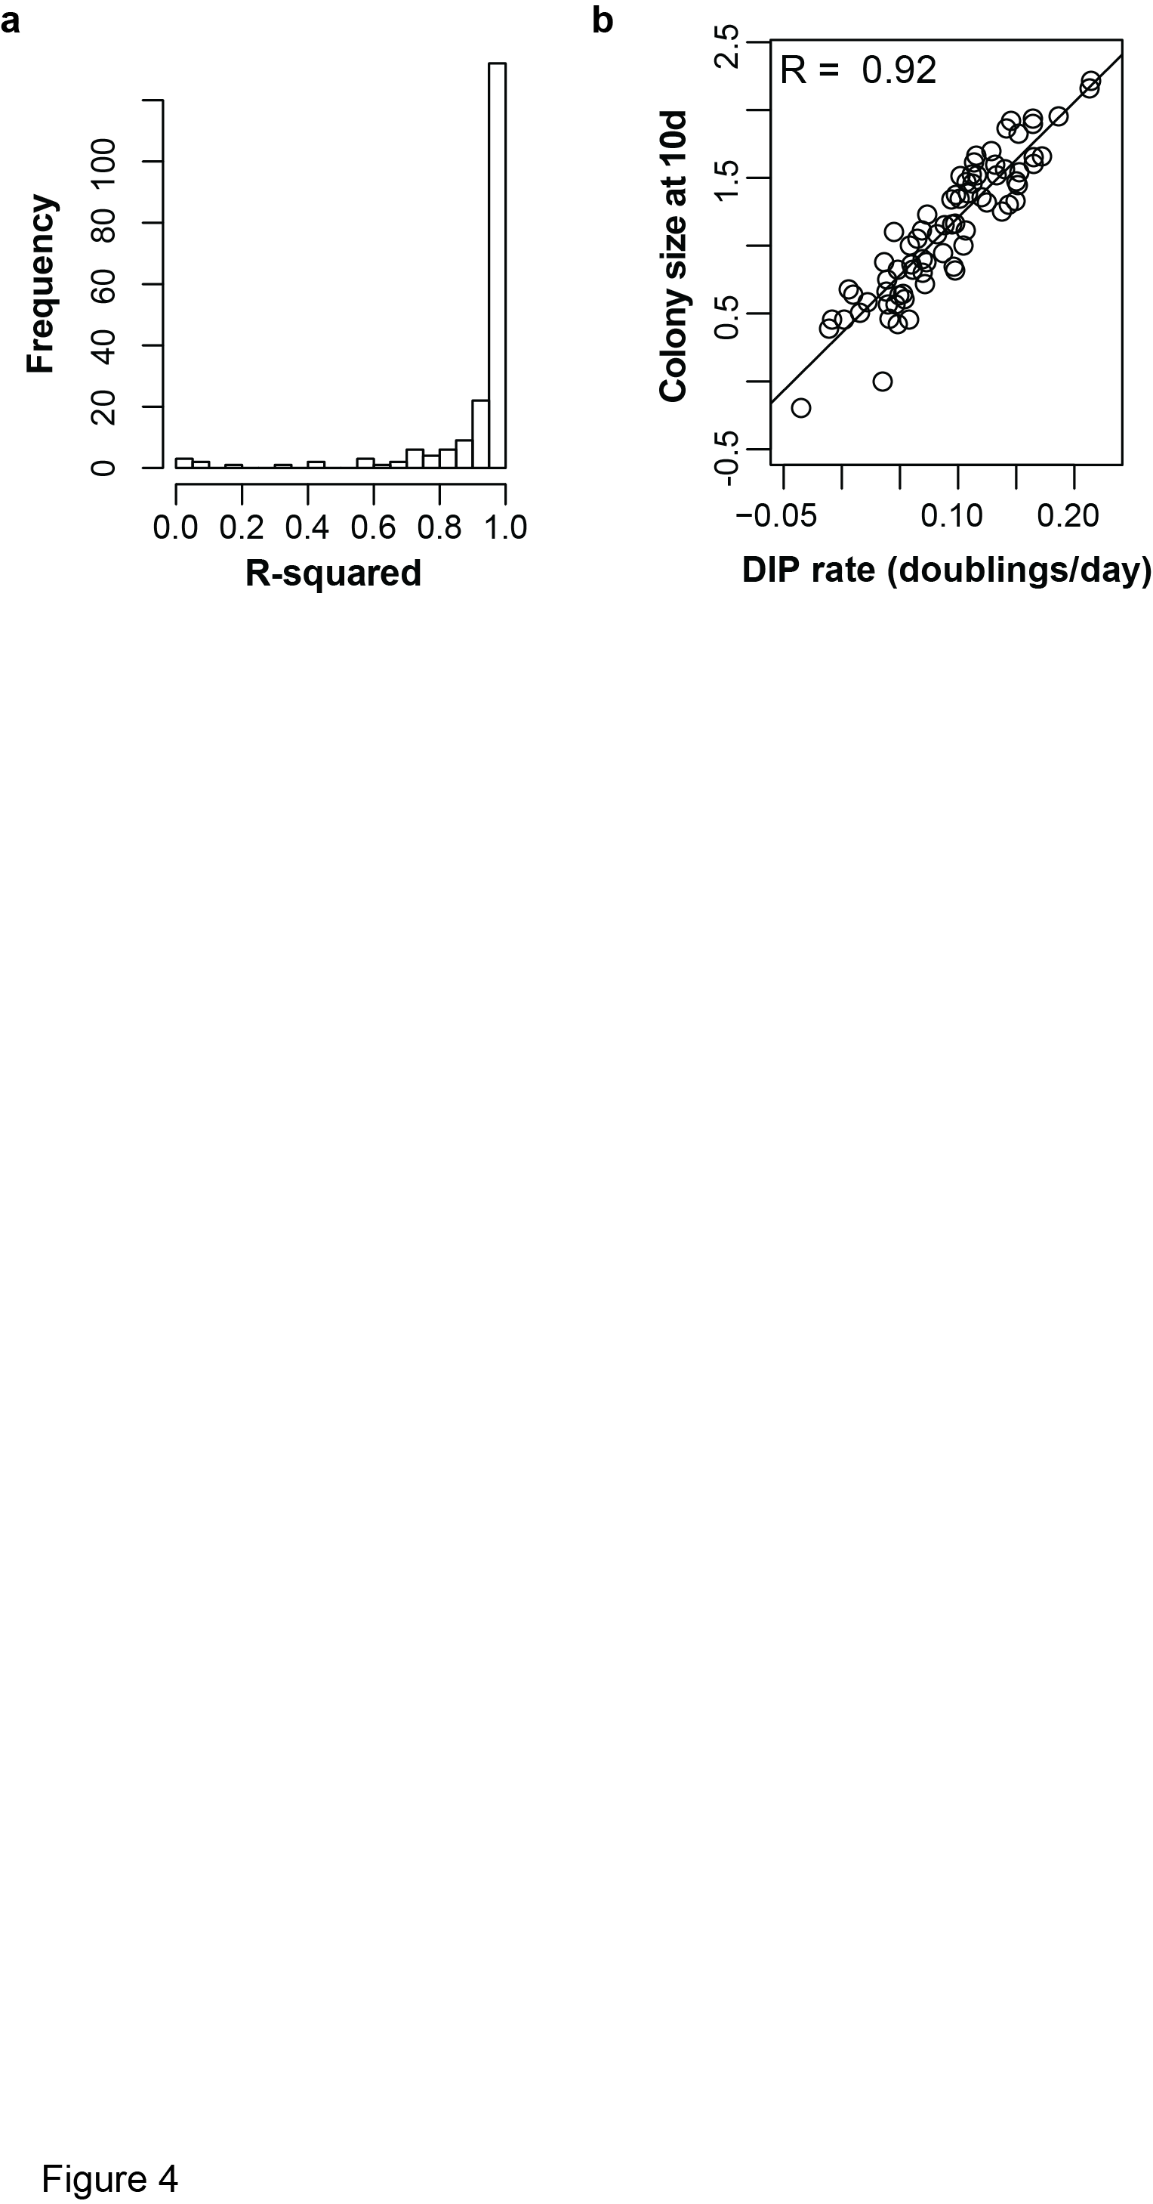

**Fig. 2.4** DIP rate correlations. (a) Colony proliferation is suitably represented by linear fits. Histogram of R-squared values from the linear model fits of all DMSO- and cycloheximide treated colonies (n=194 total). (b) DIP rates correlate with the relative colony size after 10 d cycloheximide treatment.